Hub-and-Spoke Architecture with Azure Firewall

1. Introduction
Cloud network security is an important aspect of modern cloud infrastructure. In Microsoft Azure, organizations commonly implement a Hub-and-Spoke network architecture to centralize security, connectivity, and traffic control.
In this project, a Hub-and-Spoke Virtual Network architecture was implemented using Microsoft Azure. The hub network contains Azure Firewall, which acts as the central security component.
The spoke network hosts the virtual machine that generates traffic. The firewall is configured with:
- NAT Rules
- Network Rules
- Application Rules
These rules ensure that internet traffic is filtered and controlled, allowing access only to Google services while blocking other websites.
This architecture is widely used in enterprise environments to enforce centralized security and traffic inspection.

2. Architecture Overview
The architecture contains the following components:
Hub Network
- Hub Virtual Network
- Azure Firewall
- AzureFirewallSubnet
Spoke Network
- Spoke Virtual Network
- Virtual Machine
- Workload Subnet
Connectivity
- VNet Peering between Hub and Spoke
- Route Table to force traffic through firewall
Traffic flow:
VM (Spoke) → Route Table → Azure Firewall (Hub) → Internet (Google Only)

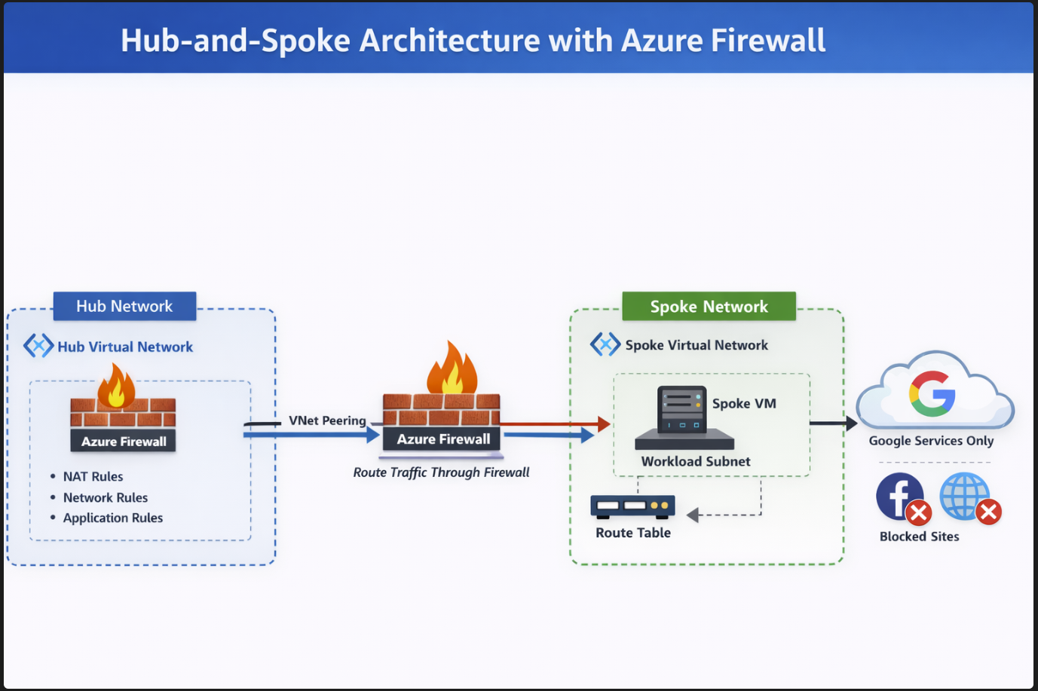

3. Prerequisites
Before starting the deployment, ensure the following:
- Active **Microsoft Azure subscription
- Access to Azure Portal
- Basic knowledge of Virtual Networks
- Resource Group created

4. Step 1 – Create Resource Group
- Login to Azure Portal
- Search for Resource Groups
- Click Create
- Enter:
Setting | Value
Resource Group Name | hub-spoke-rg
Region | Canada Central
- Click Review + Create
- Click Create
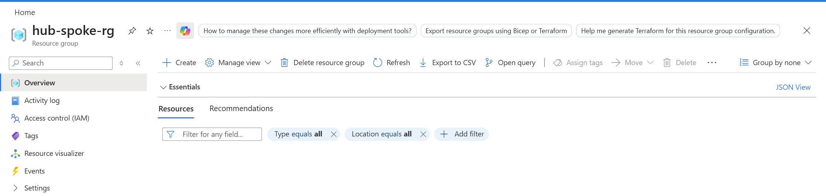
5. Step 2 – Create Hub Virtual Network
- Go to Virtual Networks
- Click Create
Configuration:
Setting | Value
Name | hub-vnet
Address Space | 10.0.0.0/16
Create Subnet:
Subnet Name | Address Range
AzureFirewallSubnet | 10.0.1.0/24
⚠️ The subnet must be named AzureFirewallSubnet for the firewall to work.
Click Review + Create
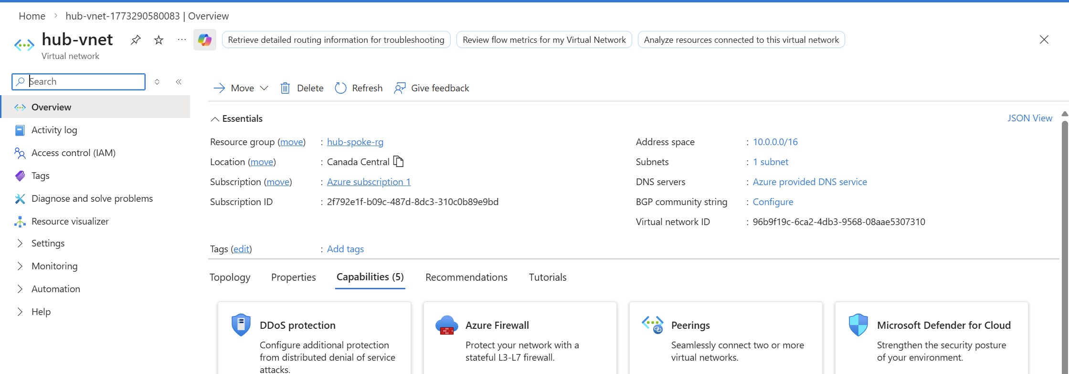
6. Step 3 – Create Spoke Virtual Network
- Navigate to Virtual Networks
- Click Create
Configuration:
Setting | Value
Name | spoke-vnet
Address Space | 10.1.0.0/16
Create subnet:
Subnet Name | Address Range
workload-subnet | 10.1.1.0/24
Click Create
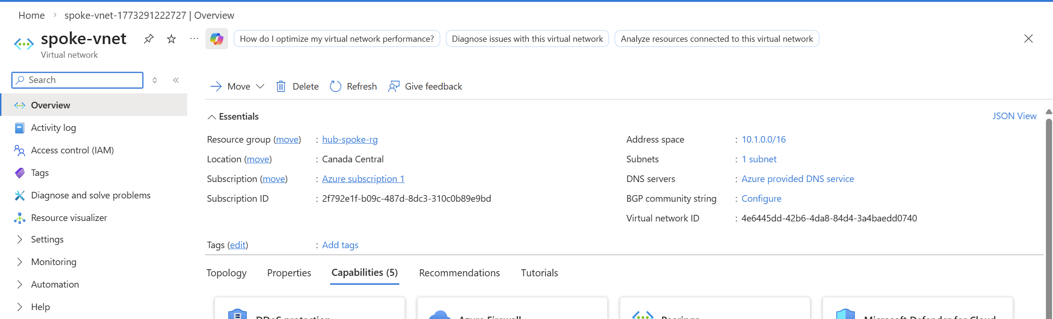
7. Step 4 – Configure VNet Peering
VNet peering allows communication between hub and spoke networks.
Peer Hub → Spoke
- Open hub-vnet
- Select Peerings
- Click Add
Configuration:
Setting | Value
Peering Name | hub-to-spoke
Remote VNet | spoke-vnet
Enable:
- Allow forwarded traffic
- Allow gateway transit
Click Add
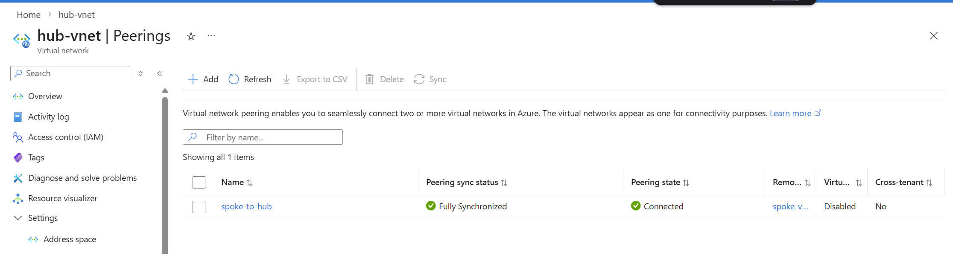
Peer Spoke → Hub
- Open spoke-vnet
- Go to Peerings
- Click Add
Configuration:
Setting | Value
Peering Name | spoke-to-hub
Remote VNet | hub-vnet
Enable:
- Allow forwarded traffic
- Use remote gateway
Click Add
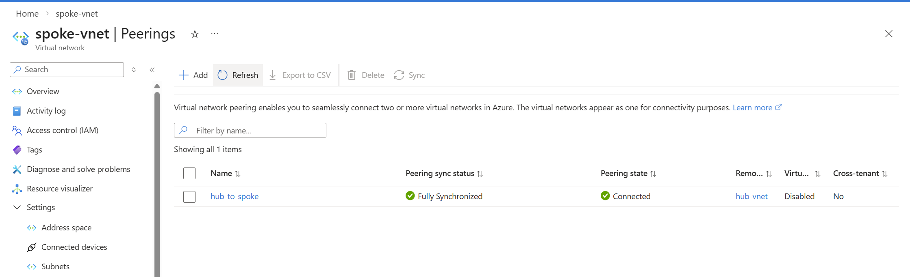
8. Step 5 – Deploy Azure Firewall
- Search Firewall in Azure Portal
- Click Create
Configuration:
Setting | Value
Name | hub-firewall
Region | Canada Central
Virtual Network | hub-vnet
Subnet | AzureFirewallSubnet
Public IP | Create New
Click Review + Create
Deployment may take 5–10 minutes.
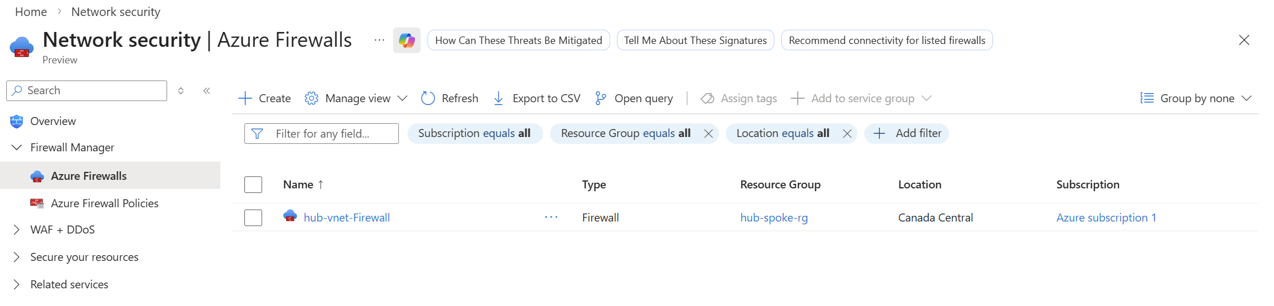
9. Step 6 – Create Route Table
A route table ensures that traffic from the spoke VM passes through the firewall.
- Go to Route Tables
- Click Create
Configuration:
Setting | Value
Name | spoke-route-table
Resource Group | hub-spoke-rg
Click Create
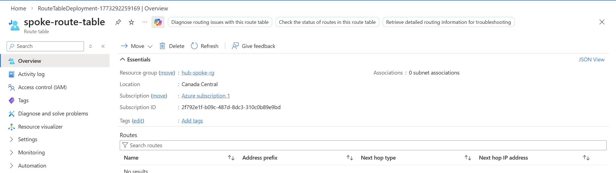
10. Step 7 – Add Route to Firewall
- Open spoke-route-table
- Click Routes
- Click Add
Configuration:
Setting | Value
Route Name | default-route
Address Prefix | 0.0.0.0/0
Next Hop Type | Virtual Appliance
Next Hop Address | Firewall Private IP
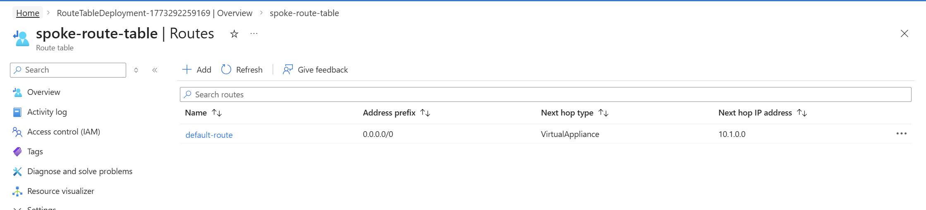
11. Step 8 – Associate Route Table with Spoke Subnet
- Open spoke-route-table
- Select Subnets
- Click Associate
Choose:
- Virtual Network → spoke-vnet
- Subnet → workload-subnet
Click Save
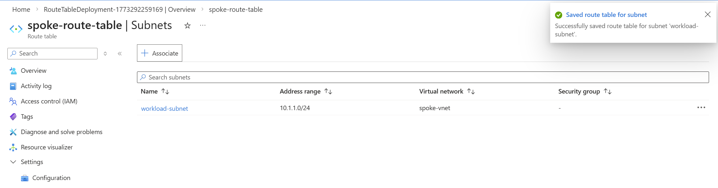
12. Step 9 – Create Virtual Machine
- Go to Virtual Machines
- Click Create
Configuration:
Setting | Value
VM Name | spoke-vm
OS | Ubuntu
VNet | spoke-vnet
Subnet | workload-subnet
Click Create
📷 Add Screenshot
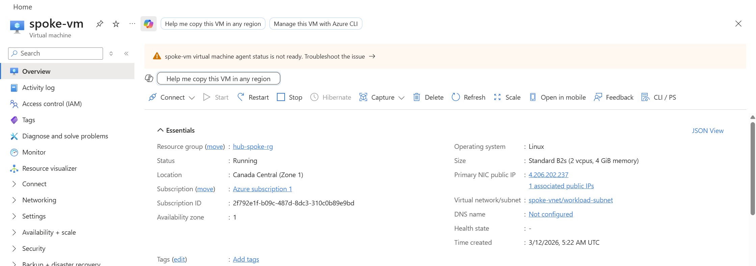
13. Step 10 – Configure Firewall Application Rule
Application rules allow access to specific websites.
- Open Azure Firewall
- Go to Rules
- Select Application Rule Collection
- Click Add Rule Collection
Configuration:
Setting | Value
Name | allow-google
Priority | 100
Action | Allow
Add rule:
Setting | Value
Name | google-access
Source | 10.1.1.0/24
Protocol | HTTP, HTTPS
Target FQDN | *.google.com
Click Add
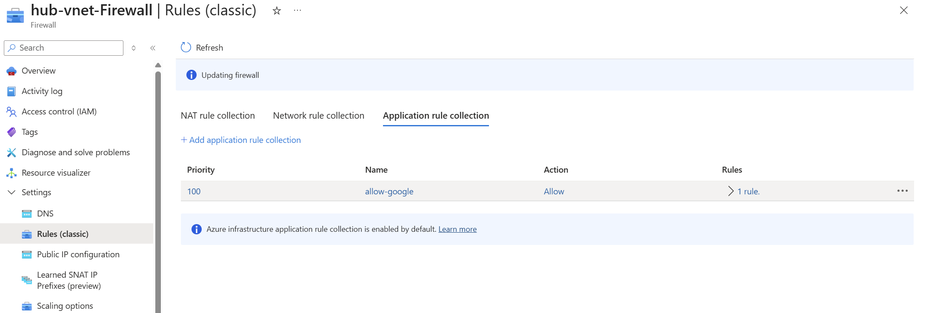
14. Step 11 – Configure NAT Rule
NAT rules allow inbound connectivity if required.
- Open Azure Firewall
- Go to NAT Rules
- Click Add Rule Collection
Example rule:
Setting | Value
Name | ssh-nat
Source | Any
Destination | Firewall Public IP
Protocol | TCP
Port | 22
Translated Address | VM Private IP
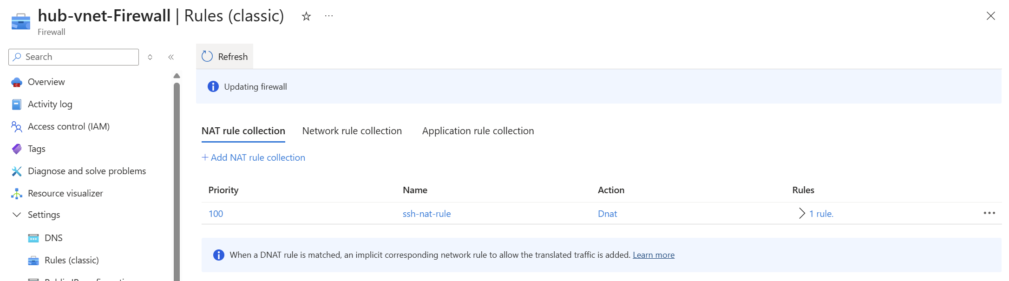
15. Step 12 – Test Connectivity
- Connect to the VM using SSH or Bastion
- Run the following commands:
Test Google:
curl https://www.google.com
Test blocked website:
curl https://www.facebook.com
Expected Result:
- Google → Works
- Other websites → Blocked
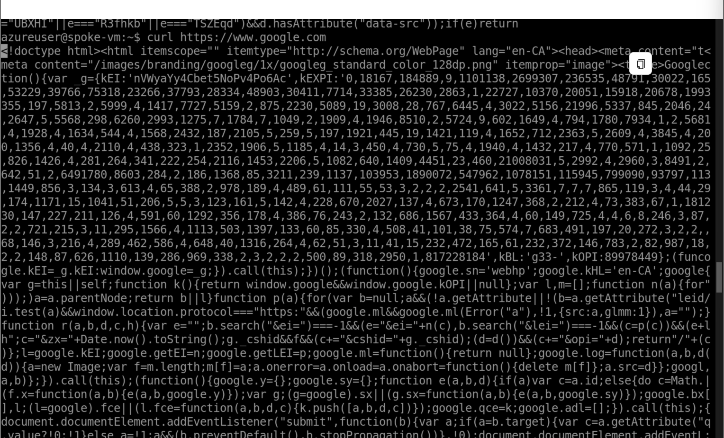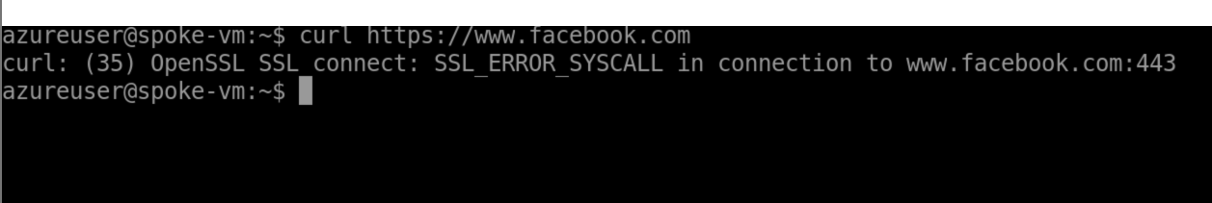

4. Conclusion
In this project, a secure Hub-and-Spoke network architecture was successfully deployed in Microsoft Azure.
The hub network hosted Azure Firewall, which controlled all internet traffic from the spoke network. Through VNet peering, route tables, and firewall rules, all outbound traffic from the virtual machine was routed through the firewall.
By implementing application rules, access was restricted to Google services only, demonstrating how Azure Firewall can enforce strict security policies.
This architecture provides centralized security, better network management, and scalable connectivity, making it suitable for enterprise cloud deployments.

